***Introduction to Version Control and Git***

**Version Control:**

Version control, also known as source code control or revision control, is a system that manages changes to documents, computer programs, and other collections of information. It is essential in software development and many other fields where multiple people collaborate on a project. Version control systems (VCS) help track and manage changes, maintain a history of revisions, and facilitate collaboration among team members.

**Git:**

Git is a widely used distributed version control system that was created by Linus Torvalds in 2005. It is designed to handle everything from small to very large projects with speed and efficiency. Git is known for its flexibility, robustness, and its ability to support non-linear development, making it a popular choice among developers and teams for managing source code and other text-based assets.

We use it to roll back the files. We can repair previous code files.

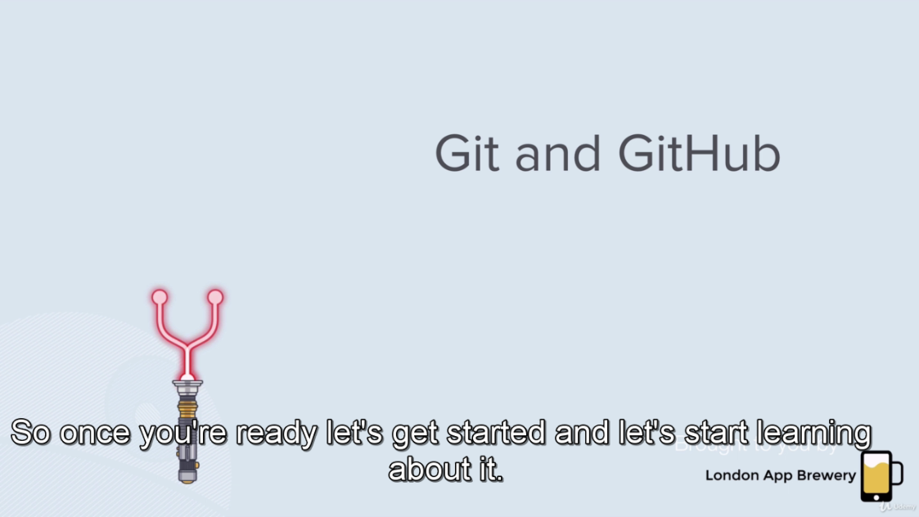

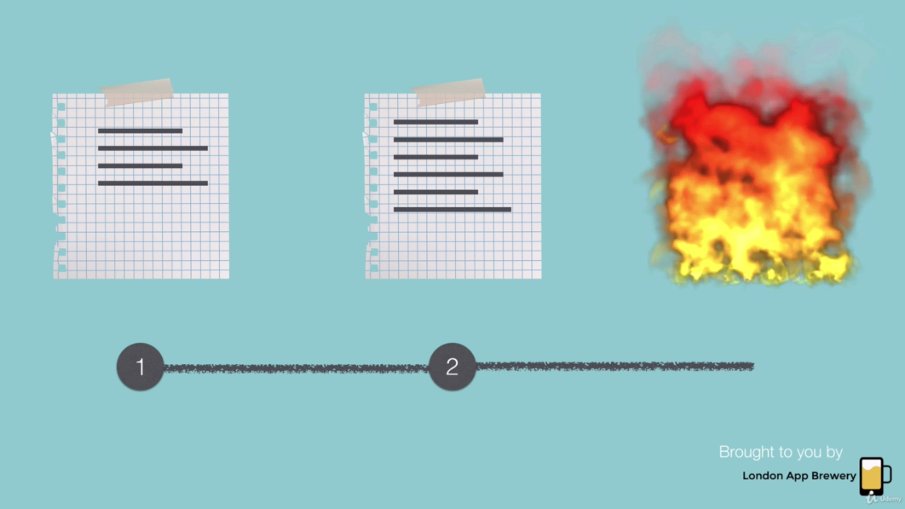

Roll back to the safe point rather than burn the whole file.

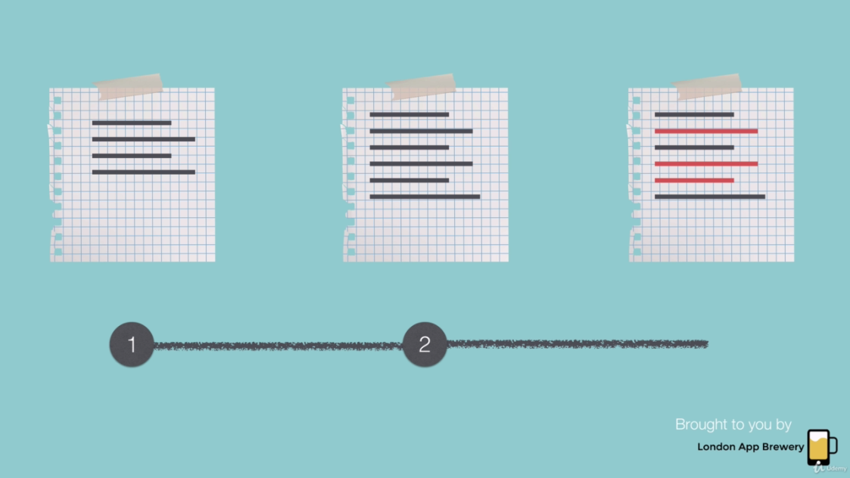

Rollback to the previous version

